Algorithm and Programming

You are assigned as a Developer for a Health Care Clinic “Health and Fit Clinic”. Your job is to create and application version 1.0 for “Health and Fit Clinic”. There are several things that you need to do :

1. **Insert the Height and Weight of the customer**

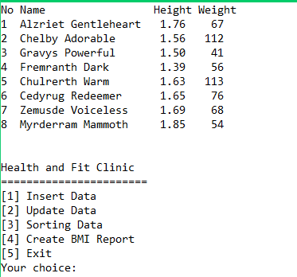

Height must be between 1.00 and 2.00 and weight must be between 40 and 120.

1. **Update the data of the customer**

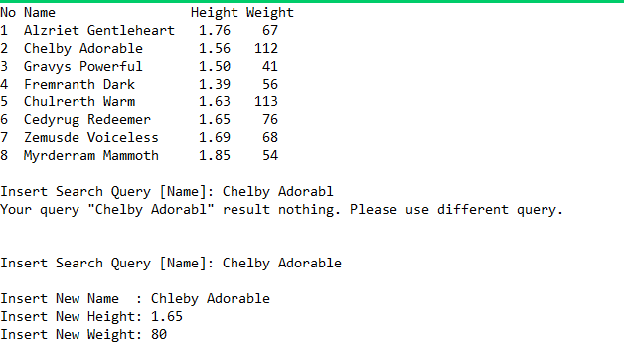

1. **Sort the name by ascending or the weight by descending**

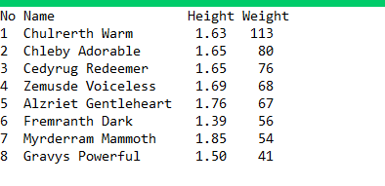

1. **Create BMI report based on :**

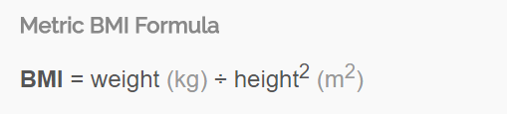

|  |  |
| --- | --- |
| **BMI** | **Classification** |
| Less than 18.5 | Underweight |
| 18.5 - 24.9 | Normal Weight |
| 25.0 - 29.9 | Overweight |
| More than 30.0 | Obese |

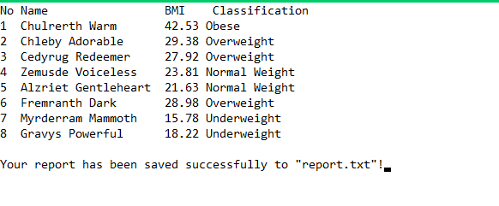

You can try the application so that you will understand more the requirement of “Health and Fit Clinic”.

----Good Luck---